Website Traffic Analysis Reports

# Traffic…

The one word that every website needs, craves for, cannot live without at all times.

Over a billion websites and the number keeps growing exponentially daily. From personal branding to consulting to business to companies to every other thing, there is a website out there for almost everything now.

This post is mainly driven towards websites that have a good amount of traffic and there are multiple solid sources. This could be anything in and above the range of 10,000 – 30,000 monthly visitors approximately. Anyone in and above this range must perform traffic analysis and know their exact traffic sources, analyze them and use that to create business goals, traffic strategies for the future (many more reasons ahead on why to do this below)

Now if “traffic analysis” seems like a lot of work, we are here to break that myth and give you three awesome ready-made templates from Supermetrics that you can instantly plug and play!

Hold your horses before we jump to the templates now!

Before doing any type of analysis, we should be aware of the WHY behind it, so let’s dig into that quickly.

# Table of Contents...

1.[Why perform Website Traffic Analysis](https://webanalyticshub.com/website-traffic-analysis/" \l "Why_perform_Website_Traffic_Analysis" \o "Why perform Website Traffic Analysis).

2.[Website Traffic Analysis Templates & Reports](https://webanalyticshub.com/website-traffic-analysis/" \l "Website_Traffic_Analysis_Templates_Reports" \o "Website Traffic Analysis Templates & Reports).

2.1. [Traffic Source Reporting Template](https://webanalyticshub.com/website-traffic-analysis/#Traffic_Source_Reporting_Template).

2.2.2. [Traffic Dashboard Reporting Template](https://webanalyticshub.com/website-traffic-analysis/#2_Traffic_Dashboard_Reporting_Template).

2.3.[3. Traffic Source Bubbles Reporting Template](https://webanalyticshub.com/website-traffic-analysis/" \l "3_Traffic_Source_Bubbles_Reporting_Template" \o "3. Traffic Source Bubbles Reporting Template).

3.How to extract insight out of these & present your clients.

# Why perform Website Traffic Analysis…

So, Why analyze your traffic? Why even waste time on this?

Here is a list of some top reasons that come out:

1. To fully and deeply understand how you get traffic from and what will happen if that stops in the future
2. To understand which is the most relevant traffic for you as per source and medium
3. To understand which traffic source is the most profitable
4. To understand which traffic source requires focus, growth, and work
5. To understand how to get more traffic per source over the next 3-6-12 months!
6. To prepare yourself for situations when any one of the traffic sources dips
7. To have a balanced distribution of traffic sources
8. To improve conversions eventually by having control over all traffic sources
9. To know who your referrers and goodwill folks are to form meaningful partnerships by reaching out to them, collaborations etc…
10. To deliver a mind-blowing report and analysis tied to your clients greatest needs and goals *(must see the last section for this)*

Eventually, [Machine Learning techniques](https://sourcedexter.com/what-is-machine-learning/) will also provide good insights extraction from your collected data.

Now, we can jump to the three templates that you can start using immediately for your website traffic analysis.

# Website Traffic Analysis Templates & Reports…

These are the three templates you need for any type of traffic analysis. Now you might be wondering why not just use Google analytics inbuilt reports and dashboards for this. Good thought!

The problem with GA (Google Analytics) inbuilt reports and dashboards are they are not customized and show a lot of things that are not needed. Here, we have created three reports that can potentially be aligned to your business goals and give you much better insights quicker than GA.

Note: All data shown from templates in images is dummy sample data shown for reference only. All templates are powered by *[Supermetrics](https://supermetrics.com/?aff=webanalyticshub" \t "_blank)* addon for complete automation

Update: All templates are now added to a new supermetrics page, so just search for the template name and you will find it on the page (Ctrl + F)

# 1.Traffic Source Reporting Template…

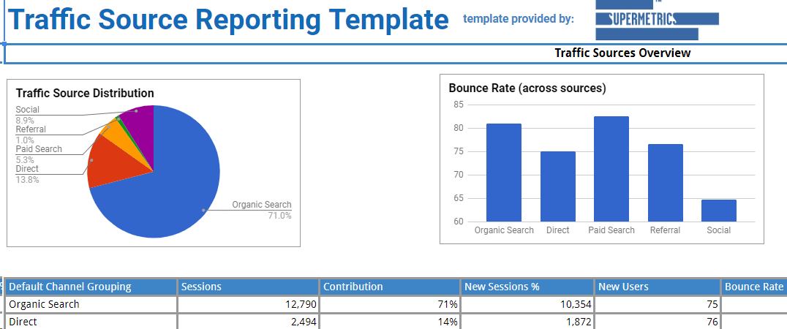

This template will give you a complete picture of traffic coming to your website. There are multiple sheets and visualizations within this template for deep-dives, different perspectives and lastly, the best action steps for your business which are described in detail below for respective sheets

1. Traffic sources – This is the executive overview of “Traffic Sources” for a certain website. This will help you understand instantly all the traffic sources at a glance from an “inbound” perspective as well as from the “device” perspective that is being used to access your website for a specific time period
2. Organic – This is a deep-dive view of “Organic” traffic by looking at the keywords and landing pages that are used by visitors to reach your site. This understanding can help you plan your next set of SEO work in a more holistic manner. It also gives you the share of each search engines traffic
3. Social – This is a deep-dive view of “Social” traffic by looking at traffic share of each social media platform and the top landing pages that have been visited via this channel. This can help you optimize your social media strategy and to further improve upon the same
4. Direct – This is a deep-dive view of “Direct” traffic by showing the page that people land at an exit from when they are coming in via this channel. Furthermore, a quick check if these two respective pages are same or not to understand which pages make the people stay on the website and which pages make them bounce off from the website
5. Paid search – This is a deep-dive view into “Paid search” traffic by showing the keywords that led to maximum clicks and the maximum impressions along with several other metrics to understand how to optimize further to improve the campaigns. For more deep-dives, check out our other templates on PPC on Supermetrics
6. Referral – This is a deep-dive view into “Referral” traffic by looking at the “Full referrer” to understand very clearly the exact source that the traffic came from along with the landing page that it came onto the website. This combination will help track referrals and their traffic contribution precisely, which can further be optimize

Balanced distribution of traffic sources – Lastly, this is one of the most important [key points](http://www.christopherspenn.com/2011/01/how-balanced-is-your-google-analytics-pie/) in this shown in the first visualization only. The website ideally should never be over-dependent on any traffic source be it organic or social or anything like that’s very risky. The distribution should always be diversified and well-balanced.

Phew! That was a lot of templates and data you can analyze for a long time.

However, most analysts are stuck in [data pukes](https://www.kaushik.net/avinash/difference-web-reporting-web-analysis/) and reporting things that are NOT needed by the business.

So, to make sure you do the analysis that is important for your business, clients and really adds value, you can follow the process below:

1. Find out your (or client’s) business goals with website traffic
2. Create a list of business questions that you have for your website
3. Now, tie these business goals and questions with the various metrics and analysis that you are doing in the templates shared above. You can do this yourself via research or [hire a data person](http://webanalyticshub.com/about/) (data analyst/scientist) if you want professional help
4. After listing down various analysis and metrics for each business question – you need to eliminate everything that is not helping you focus on your goals
5. Now, you can go ahead and present this to your clients and they will be hugely interested because you will be talking in their language of business goals and questions rather than just analysis that you have thought of

This is very similar to the [KPIs framework](http://webanalyticshub.com/ecommerce-metrics/) that I have showcased to choose the most important metrics for your business.

All the above should be enough to get you moving super fast ahead in adding value to your client’s traffic strategies. You can start a free trial with [Supermetrics](https://supermetrics.com/?aff=webanalyticshub) now and you can see all these templates and much more in the “template gallery” option in the Google sheets add-on.

Now, that you have seen and used all the three templates, you will have a much deeper understanding of your traffic and what to do about it in the future

This is a continuous process and should be done a few times every 3-6-12 months depending on your business goals. You can always [reach out to us](http://webanalyticshub.com/contact/) if you need any help with all the above analysis and much more.

Let me know your thoughts in comments and I’d be happy to answer them for you.

Phew! That was a lot of templates and data you can analyze for a long time.

However, most analysts are stuck in [data pukes](https://www.kaushik.net/avinash/difference-web-reporting-web-analysis/) and reporting things that are NOT needed by the business.

So, to make sure you do the analysis that is important for your business, clients and really adds value, you can follow the process below:

1. Find out your (or client’s) business goals with website traffic
2. Create a list of business questions that you have for your website
3. Now, tie these business goals and questions with the various metrics and analysis that you are doing in the templates shared above. You can do this yourself via research or [hire a data person](http://webanalyticshub.com/about/) (data analyst/scientist) if you want professional help
4. After listing down various analysis and metrics for each business question – you need to eliminate everything that is not helping you focus on your goals
5. Now, you can go ahead and present this to your clients and they will be hugely interested because you will be talking in their language of business goals and questions rather than just analysis that you have thought of

This is very similar to the [KPIs framework](http://webanalyticshub.com/ecommerce-metrics/) that I have showcased to choose the most important metrics for your business.

All the above should be enough to get you moving super fast ahead in adding value to your client’s traffic strategies. You can start a free

trial with [Supermetrics](https://supermetrics.com/?aff=webanalyticshub) now and you can see all these templates and much more in the “template gallery” option in the Google sheets add-on.

Now, that you have seen and used all the three templates, you will have a much deeper understanding of your traffic and what to do about it in the future

This is a continuous process and should be done a few times every 3-6-12 months depending on your business goals. You can always [reach out to us](http://webanalyticshub.com/contact/) if you need any help with all the above analysis and much more.

Let me know your thoughts in comments and I’d be happy to answer them for you.

# 2. [Traffic Dashboard Reporting Template](https://supermetrics.com/template-gallery/google-sheets?aff=webanalyticshub)…

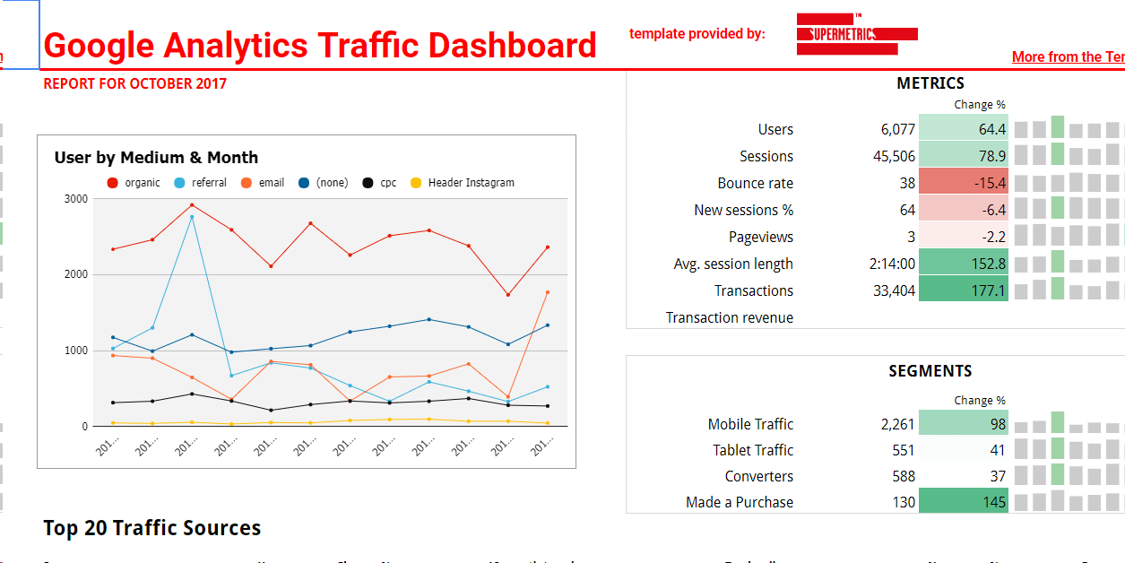

This shows a quick distribution as per source/medium of all traffic sources to take a further deep-dive within that area.

This can give you a slightly different view due to all the sources that are not counted in the default channels shown by GA. The conditional formatting has been added to understand if there are some changes in trends that are harmful for the website.

There are running 12-month trends for each source and also at an overall level to get contextual data and comparisons for your website so you can really take the best data-driven action steps.

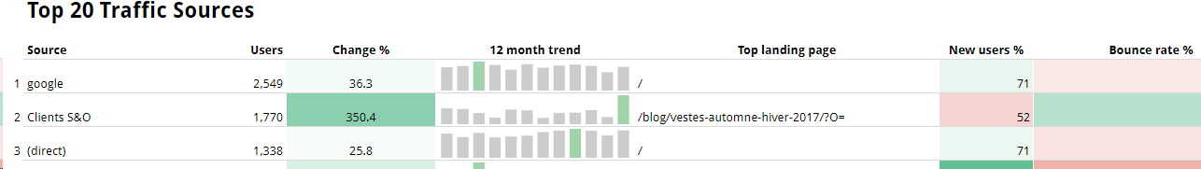

Lastly, it shows segments of the sources along with it.

# 3.[Traffic Source Bubbles Reporting Template](https://supermetrics.com/template-gallery/google-sheets?aff=webanalyticshub" \t "_blank)…

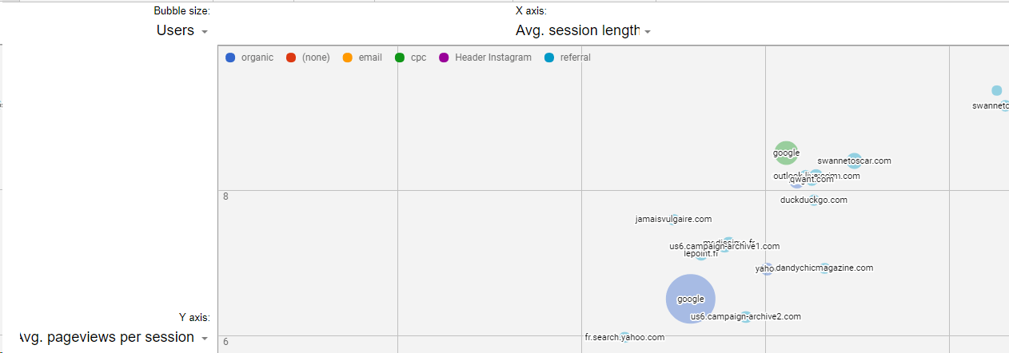

Lastly, we have the traffic source bubbles to give you a holistic quick view directly of all the traffic sources, their users and session length directly.

The bubble size, X and Y axis are representations of all of these dimensions and they can be interchanged as per the end user for various perspectives.

This is the eagle eye view for your entire traffic in one single large visualization to find things that you have missed in all the templates and work discussed above.

These were the set of traffic analysis templates only. If you are a digital marketer, analyst and want some more templates, make sure you check out the entire Templates gallery by Supermetrics for much more ready to use templates, which is now broken down by PPC, Analytics, Social and Trending also for ease of use

# How to Extract Insights out of these & Present to your Clients…

Phew! That was a lot of templates and data you can analyze for a long time.

However, most analysts are stuck in [data pukes](https://www.kaushik.net/avinash/difference-web-reporting-web-analysis/) and reporting things that are NOT needed by the business.

So, to make sure you do the analysis that is important for your business, clients and really adds value, you can follow the process below:

1. Find out your (or client’s) business goals with website traffic
2. Create a list of business questions that you have for your website
3. Now, tie these business goals and questions with the various metrics and analysis that you are doing in the templates shared above. You can do this yourself via research or [hire a data person](http://webanalyticshub.com/about/) (data analyst/scientist) if you want professional help
4. After listing down various analysis and metrics for each business question – you need to eliminate everything that is not helping you focus on your goals
5. Now, you can go ahead and present this to your clients and they will be hugely interested because you will be talking in their language of business goals and questions rather than just analysis that you have thought of

This is very similar to the [KPIs framework](http://webanalyticshub.com/ecommerce-metrics/) that I have showcased to choose the most important metrics for your business.

All the above should be enough to get you moving super fast ahead in adding value to your client’s traffic strategies. You can start a free trial with [Supermetrics](https://supermetrics.com/?aff=webanalyticshub) now and you can see all these templates and much more in the “template gallery” option in the Google sheets add-on.

Now, that you have seen and used all the three templates, you will have a much deeper understanding of your traffic and what to do about it in the future

This is a continuous process and should be done a few times every 3-6-12 months depending on your business goals. You can always [reach out to us](http://webanalyticshub.com/contact/) if you need any help with all the above analysis and much more.

# Let me know your thoughts in comments and I’d be happy to answer them for you…,